**PROFBIO Tema 3**

**Atividade 2: Alelos da tirosinase – parte 1**

Observe a figura abaixo:

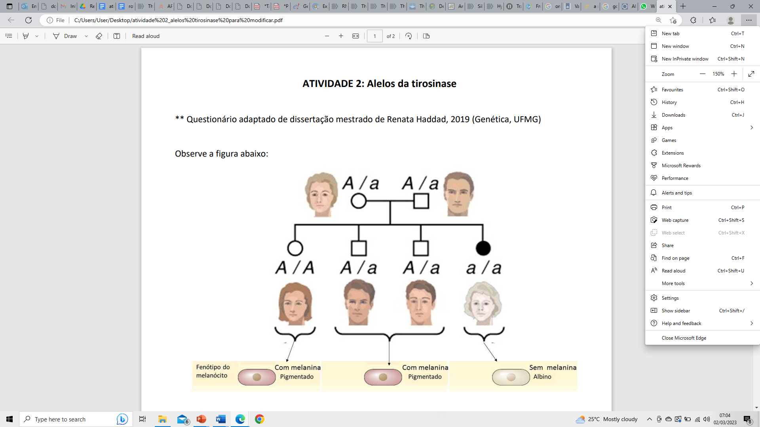

1. As letras “A” e “a” representam alelos de um gene relacionado a produção de melanina. A relação entre as letras A/A, A/a e a/a na gravura é de dominância e recessividade. Explique como essas interações se relacionam em termos genético-bioquímicos (transcrição, tradução e proteína).

____________________________________________________________________________________________________________________________________________________________________________________________________________________________________________________________________________________________________________________________________________________________________________________________________________________________________________________________________________________________________________________________________________________________________________________________________________________________________________________________________________________________________________________________________________________________________________________________________________________________________________________________________________________________________________________________________________________________________________________________________________